## Test Data Modeling

A Data Model provides a solution to identify all table relationships across multiple data sources in an environment. A Data Model is created using the relationships discovered during a scan. This Data Model allows you to visualize the relationships between table and data sources, so you can better understand data usage in your Environment.

**Pre-requisites:**

1. Create project and version in **CA TDM portal**.
2. Create and shared a connection profiles (**Data Reservation** connection profile created in this).
3. Registered the required **objects** for creating test data model.

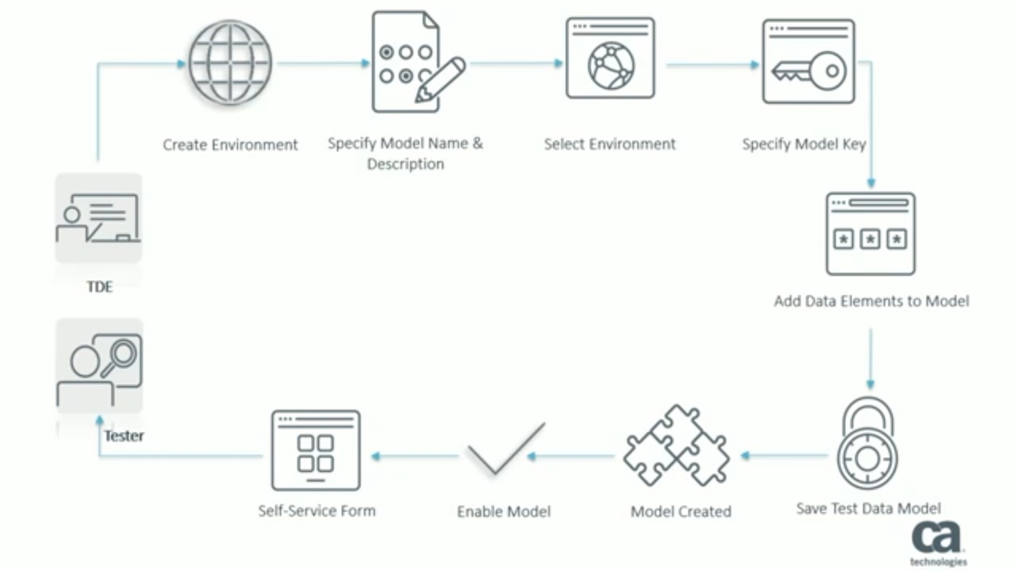 **Figure 1: Test Data Model creation workflow**

**Step 1:** Create an **environment**. Environment is a collection of all data sources used by an application. If your application connects to three different databases, each environment will have three data sources specified using a connection profile. Click on **modeling** in the left panel and select **environment** from dropdown.

Select **new environment**, enter the details in the following fields and save. Add data source to provide connection profile created as pre-requisite.

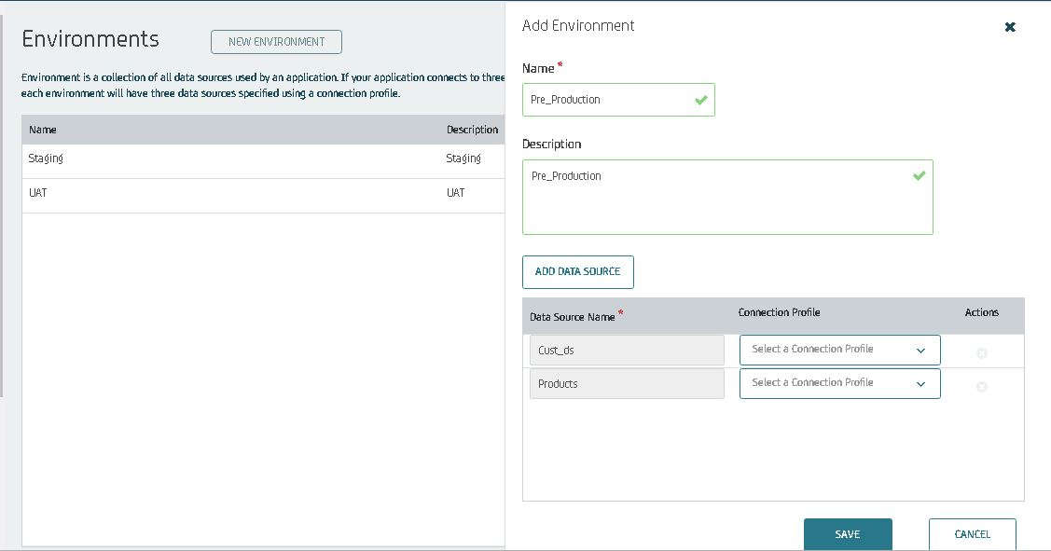 Similarly create for three phases.

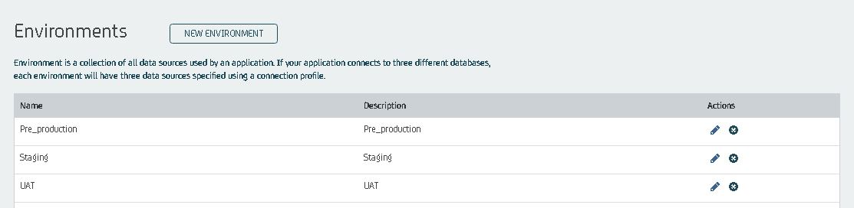**Step 2:** Click on **modeling** and select **Test Data Model** from drop-down. Specify test data model name and description.

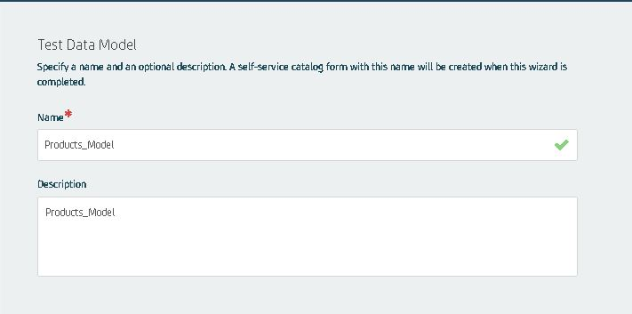

**Step 3:** Select the **environment** in which test data model must be created.

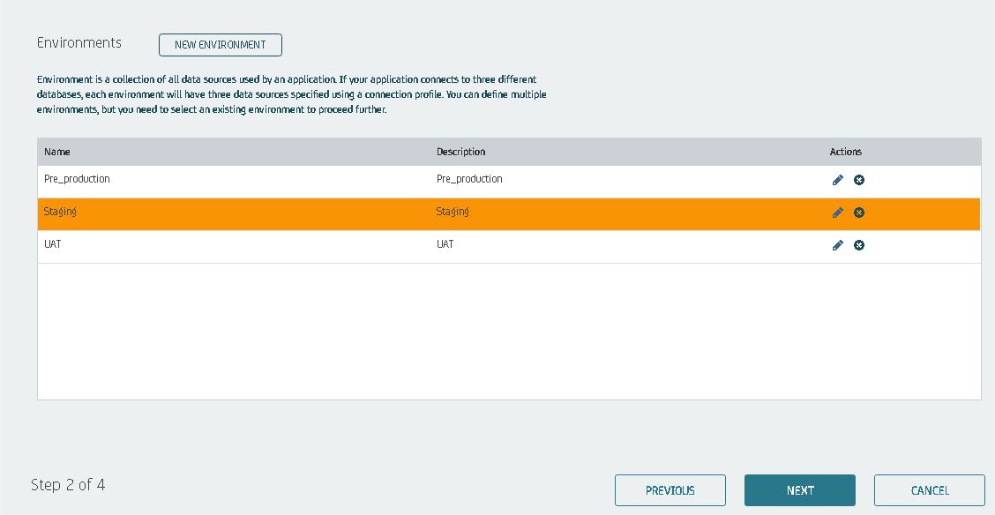

**Step 4:** Specify **model key**. Model key derives the **reservation** of records across the test data model. One or more fields can be selected for a model key. The **model key** is typically the **primary key** of uppermost table in the hierarchy.

Expand the table **(product table** is used in this scenario)select the **Id** and clicks on **forward pane**. Enter the details in the corresponding fields and save.

Note: Display in **Tester self Service** checkbox must be checked.

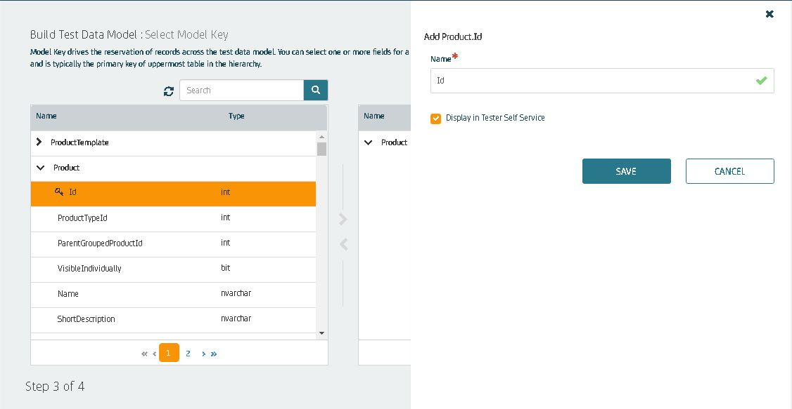

**Step 5:** Adding some more fields either from same table or different table. Repeat the step 4 and add the required fields.

For additional fields from different table specify the **relationship** from the super table and column which is common in both. Click on next and save. Once completed adding all the fields from all the tables click on finish.

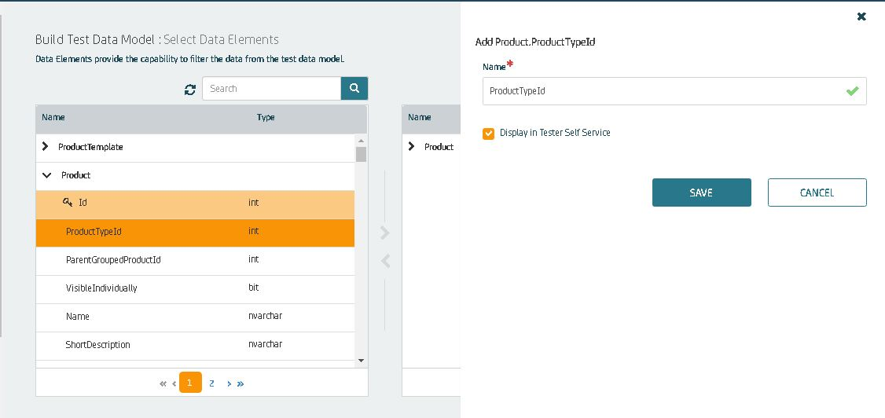

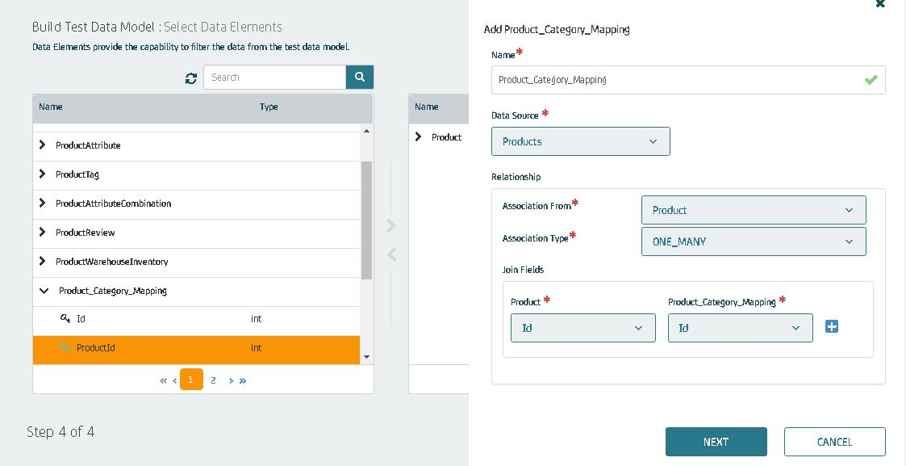

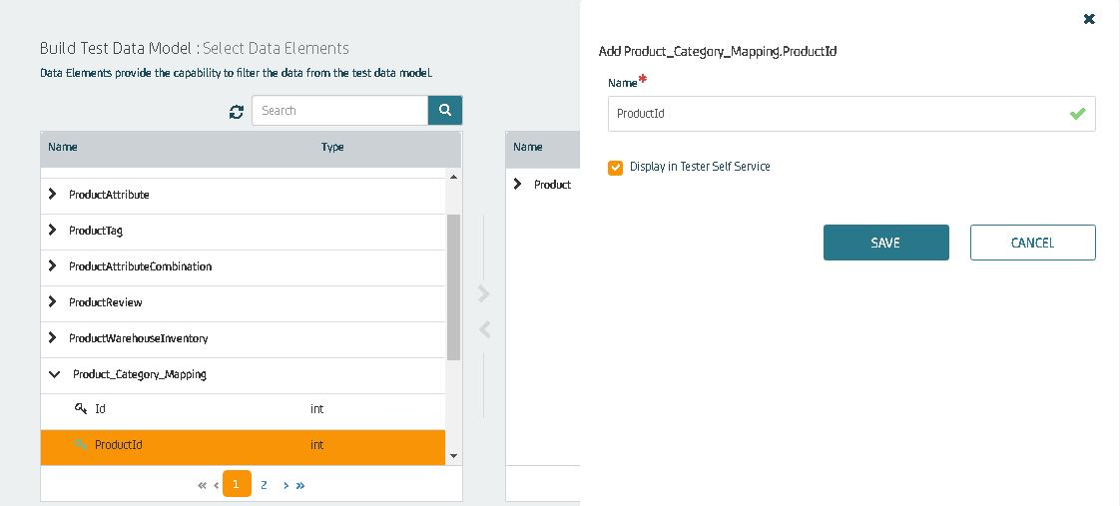

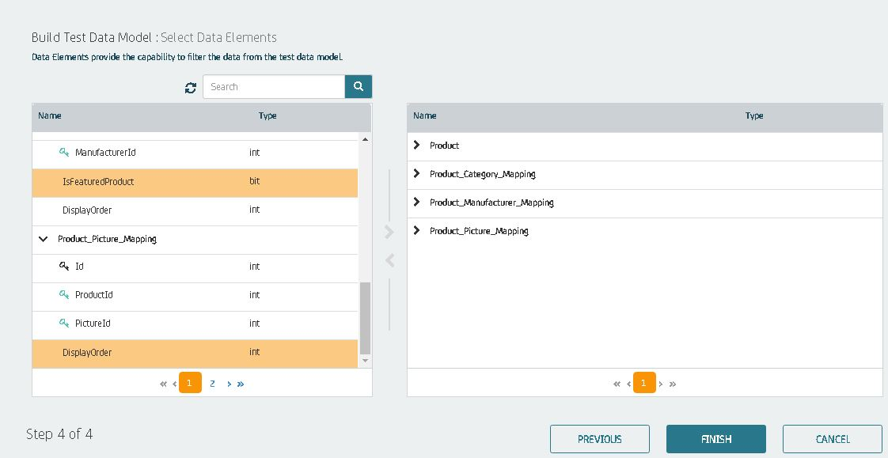

**Step 6:** After successfully adding all the fields. Click on finish and **test data model** is built. To enable testers to find and reserve the data, toggle **display to tester** as **YES**.

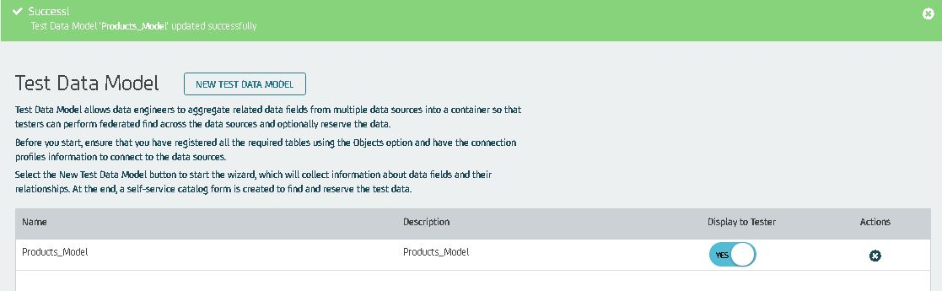

Newly created test data model will be available in **self-service catalogue**.

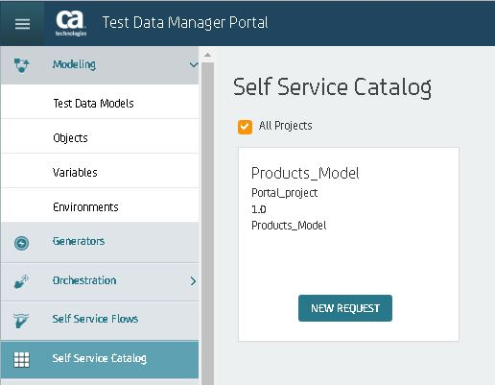

## Data Reservation in TDM Portal

**Pre-requisite**

1. A valid login account to the **CA TDM Portal** with access to the **self-service catalogue**.
2. The test data model should be created and configured a self-service form specific to the required data.

**Step 1:** Access the CA TDM Portal as a tester.

**Step 2 :** Select appropriate project and version from the Project drop-down list.

**Step 3 :** Click Self Service Catalog in the left pane. The Self Service Catalog page opens.



**Step 4 :** Locate the specified(**Product_Model** used in this scenario)catalog.

**Step 5 :** Click the **New** **Request button**. The **Product_Model** page opens.

**Step 6 :** Select **Staging** as an environment from the **Environment** drop-down list.

**Step 7:** Enter the **test data filter** criteria in the available fields as required. Click the **Find Data** button. The Portal uses the defined filter criteria, retrieves the data from the applicable data source, and displays the retrieved data.

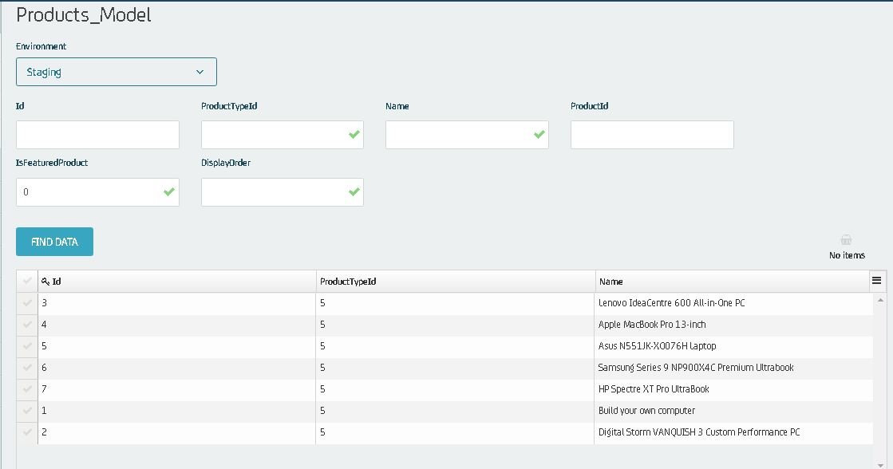

**Step 8 :** Review the **displayed** **data** and click the **tick mark** to select the records that you want to **reserve**. The **Reserve button** is enabled. Click the **Reserve button**. The Add a name to your Reservation dialog opens. Enter the **name of the reservation** and click on **reserve**.

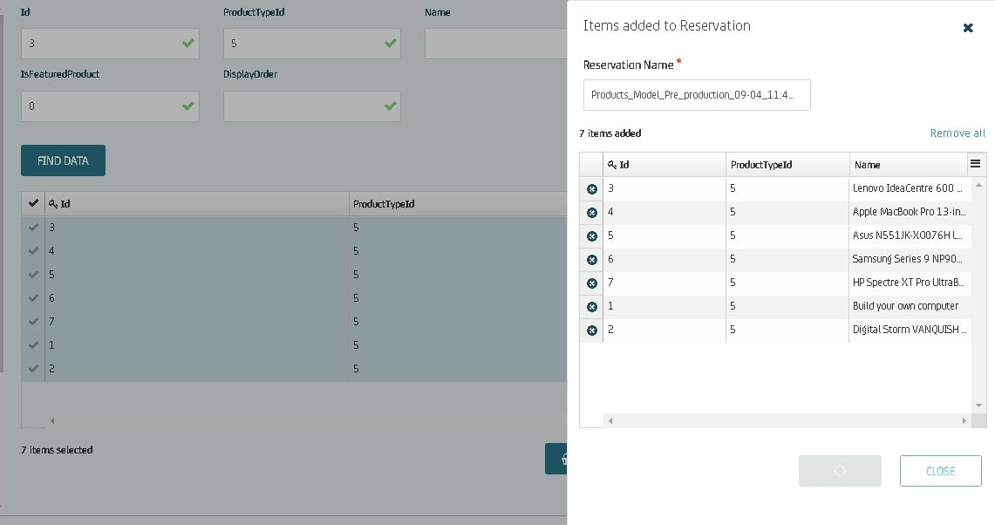

**Step 9 :** A message states that the **Products_Model_Staging_09-04_11:31 AM** reservation request is submitted **successfully**. Click the **Products_Model_Staging** link in the message. The **My Reservations** page opens. This page lists all the data reservations. 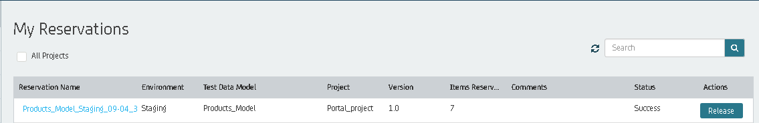

**Step 10 :** Identify and click the **Products_Model_Staging reservation**. The **Products_Model_Staging** page opens. This page displays **relevant information** about the reservation. For example, **environment name, test data model name, project name, version name, number of records reserved, status of the reservation.** 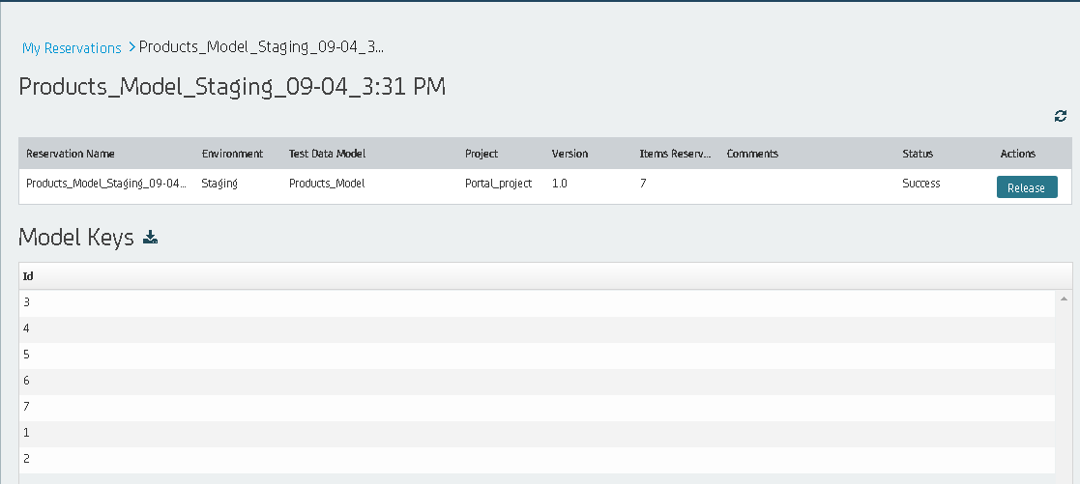

**Step 11 :** Review the reservation status as **Success.**

## References

1. **Data Reservation**: <https://docops.ca.com/ca-test-data-manager/4-1/en/provisioning-test-data/configure-test-data-reservation-service/configure-dynamic-test-data-reservation-service/example-order-management-system>.
2. **Test Data Model**: <https://www.youtube.com/watch?v=Bd00USxjboo>